Member State: **Estonia**

A summary of soil related issues and trends based on the analysis of a range of datasets providing a comparable perspective across the European Union (EU). It should be noted that the information displayed in this fact sheet may differ from data collected by the Member State, which reflect different spatial detail, methodologies (e.g. monitoring v modelling) or timeframes.

**Main use of soils**

|  |  |  |  |  |  |  |  |  |
| --- | --- | --- | --- | --- | --- | --- | --- | --- |
| **UAA**  **(Million ha)** | **UAA as % of land** | **Arable**  **(% UAA)** | **Organic**  **(% UAA)** | **Permanent**  **(% UAA)** | **Grassland**  **(% UAA)** | **Woodland**  **(% UAA)** | **Artificial**  **(%)[1]** | **Irrigation (% UAA)[2]** |
| 1.0 | 22 | 69.0 | 18.2 | 0.3 | 30.6 | 16.0 | 2.0 | 0.2 |

**Soil erosion by water[3]**

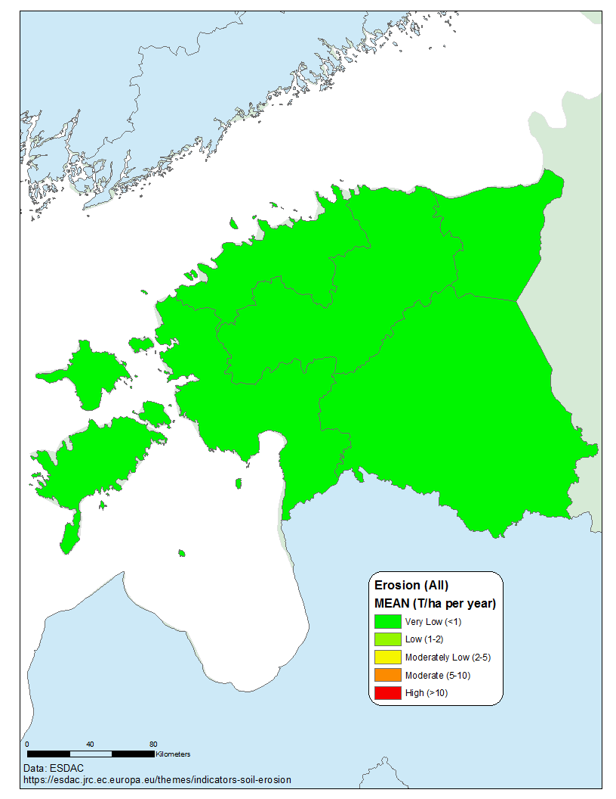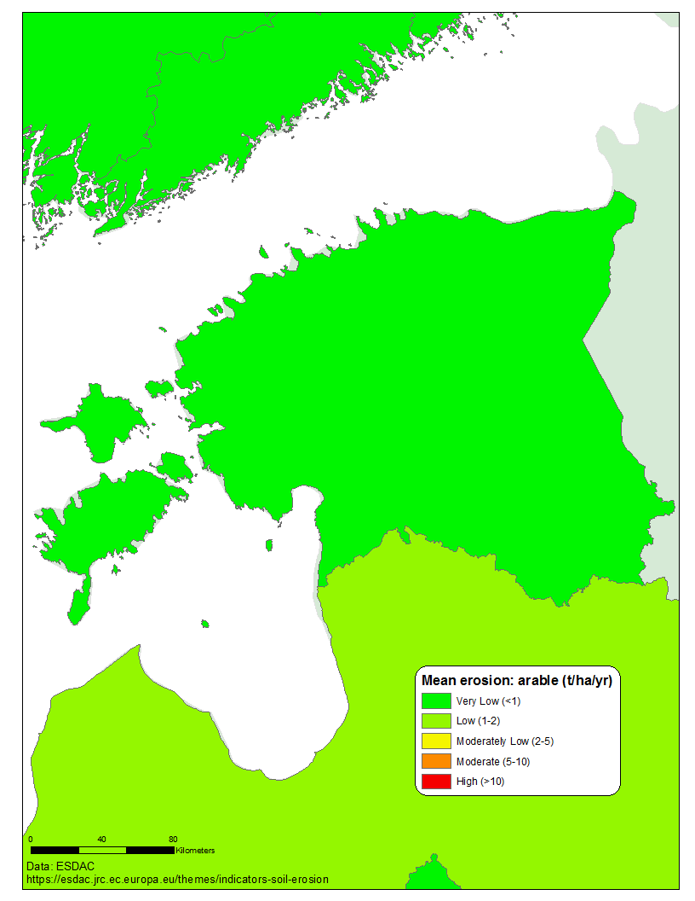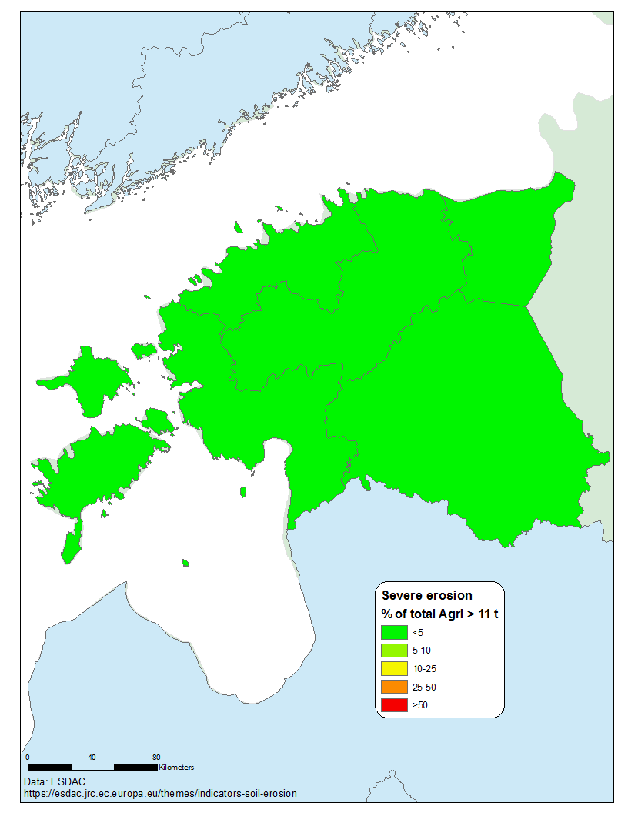

Mean soil erosion by water (2016) t ha-1 yr-1: 0.19

Highest mean rate (t ha-1 yr-1): 0.2 (Kesk-Eesti)

Short-term trend (% per decade): -11.33 ↑

% agricultural land with moderate-severe erosion (EU): 0 (6.6)

% arable/perm. crops with moderate-severe erosion (EU): 0 (7.2)

% grassland with moderate-severe erosion (EU): 0 (4.5)



**Soil organic carbon stocks**[4]

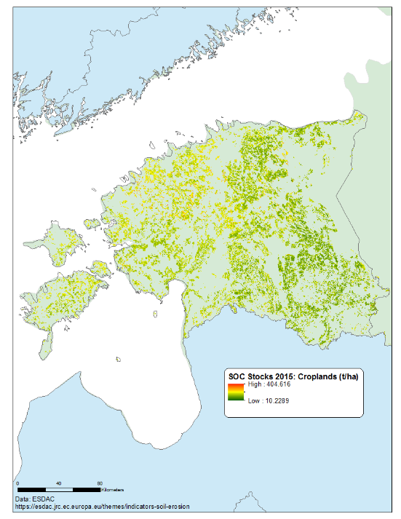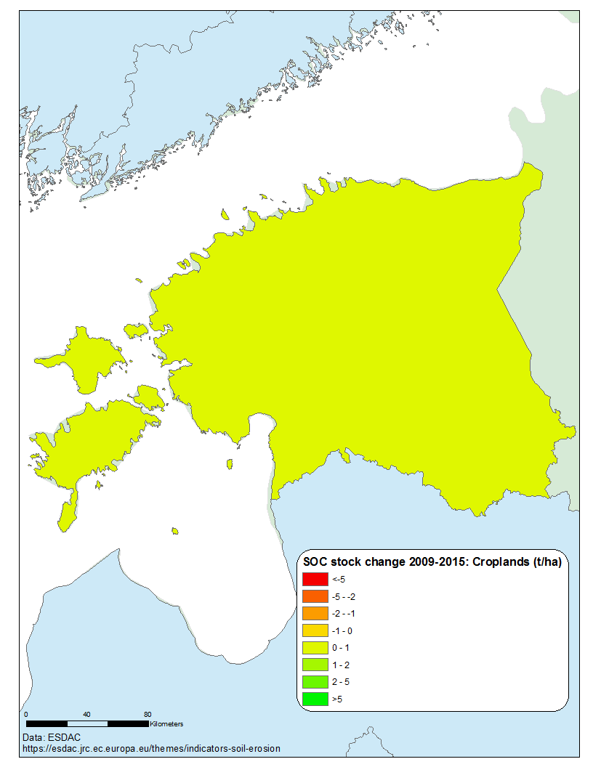

|  |  |
| --- | --- |
|  |  |

Cumulative soil organic carbon stocks – arable (Mt): 83.1

Cumulative soil organic carbon stocks – grassland (Mt): 37.8

Change in arable stocks 2009-2015 (Mt): 0

Change in grassland stocks 2009-2015 (Mt): -0.023

**Sealing[5][6][7]**

Soil sealing is a component of land take. Generally speaking, about 50% of land take results in sealed soils.

 

 

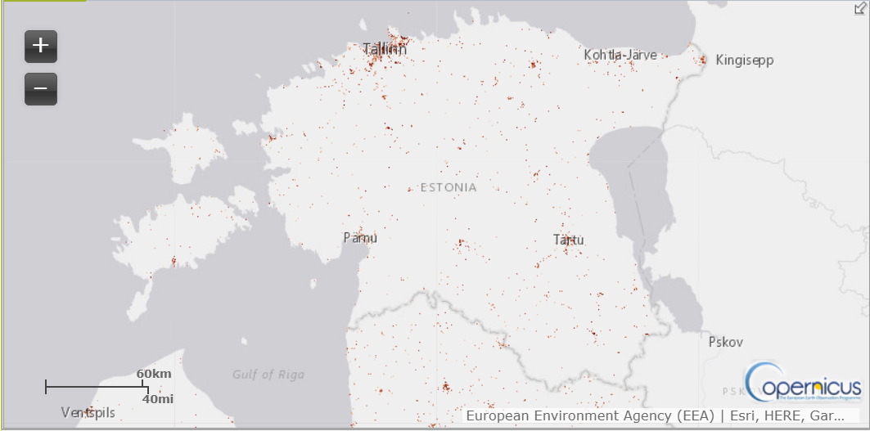

The extent of sealed soils

1. https://ec.europa.eu/eurostat/web/lucas/data/database
2. https://ec.europa.eu/eurostat/statistics-explained/index.php/Agri-environmental_indicator_-_irrigation
3. https://esdac.jrc.ec.europa.eu/themes/indicators-soil-erosion
4. Panagos et al 2020. Soil-related indicators to support agri-environmental policies
5. https://www.eea.europa.eu/airs/2018/natural-capital/urban-land-expansion
6. https://www.eea.europa.eu/data-and-maps/indicators/land-take-3/assessmen
7. https://land.copernicus.eu/pan-european/high-resolution-layers/imperviousness/status-maps/imperviousness-density-2018