Member State: **Netherlands**

A summary of soil related issues and trends based on the analysis of a range of datasets providing a comparable perspective across the European Union (EU). It should be noted that the information displayed in this fact sheet may differ from data collected by the Member State, which reflect different spatial detail, methodologies (e.g. monitoring v modelling) or timeframes.

**Main use of soils**

|  |  |  |  |  |  |  |  |  |
| --- | --- | --- | --- | --- | --- | --- | --- | --- |
| **UAA**  **(Million ha)** | **UAA as % of land** | **Arable**  **(% UAA)** | **Organic**  **(% UAA)** | **Permanent**  **(% UAA)** | **Grassland**  **(% UAA)** | **Woodland**  **(% UAA)** | **Artificial (%)[1]** | **Irrigation (% UAA)[2]** |
| 1.8 | 44 | 57.2 | 2.9 | 2.1 | 40.6 | 0.4 |  | 11.2 |

**Soil erosion by water[3]**

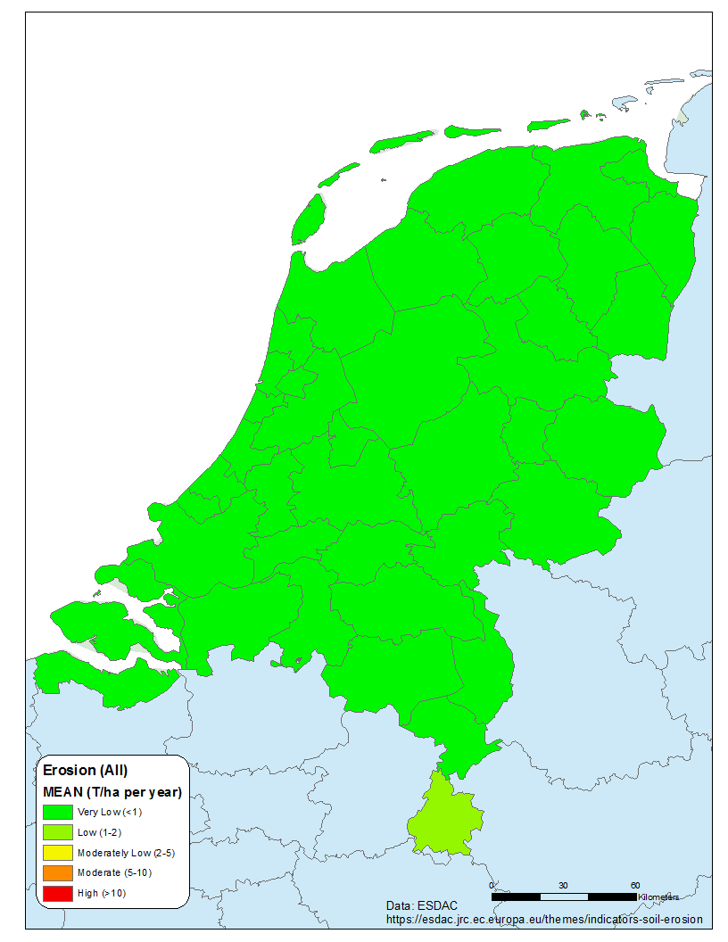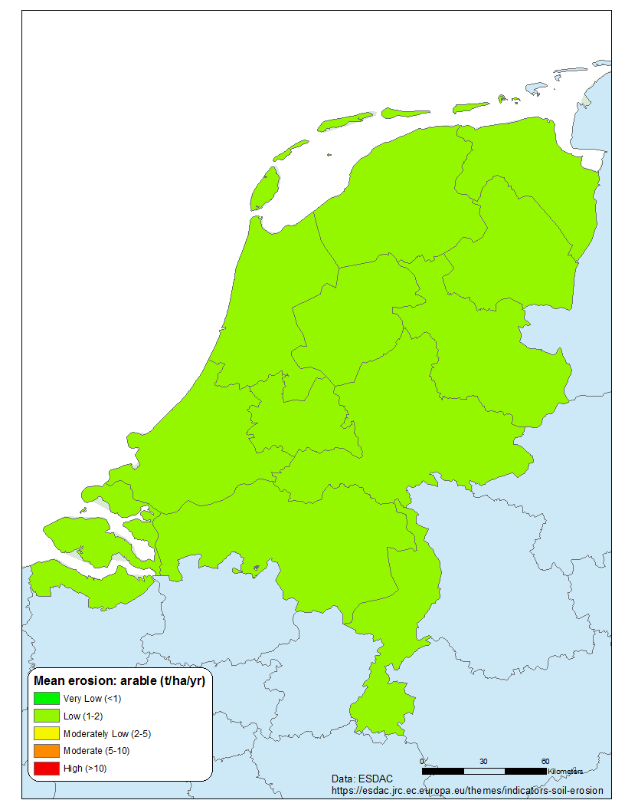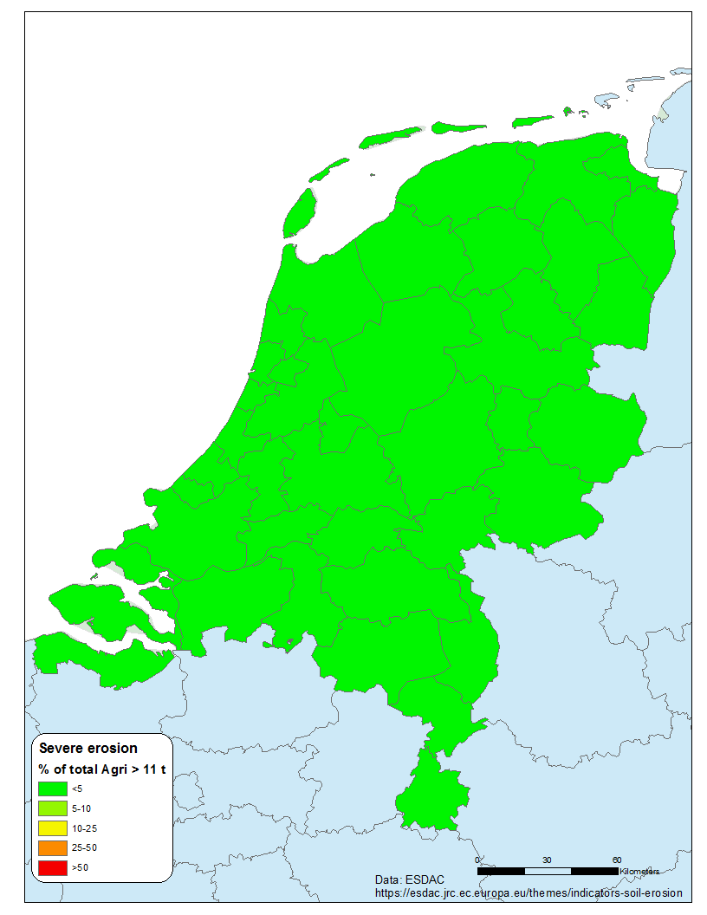

Mean soil erosion by water (2016) t ha-1 yr-1: 0.26

Highest mean rate (t ha-1 yr-1): 1.45 (South Limburg)

Short-term trend (% per decade): -4.17 →

* % agricultural land with moderate-severe erosion (EU): 0 (6.6)
* % arable/perm. crops with moderate-severe erosion (EU): 0 (7.2)

% grassland with moderate-severe erosion (EU): 0 (4.5)



**Soil organic carbon stocks**[4]

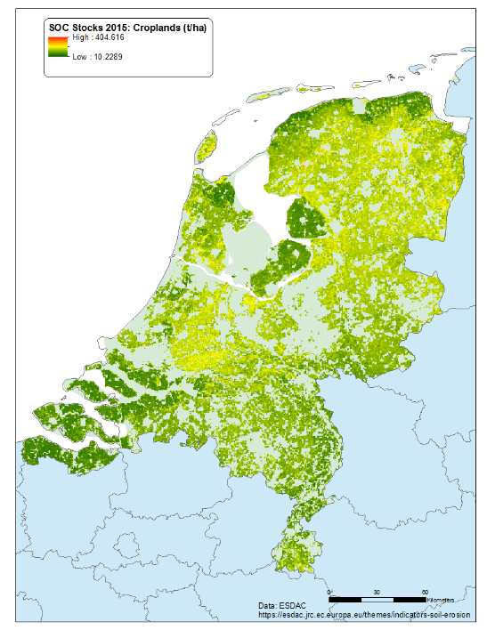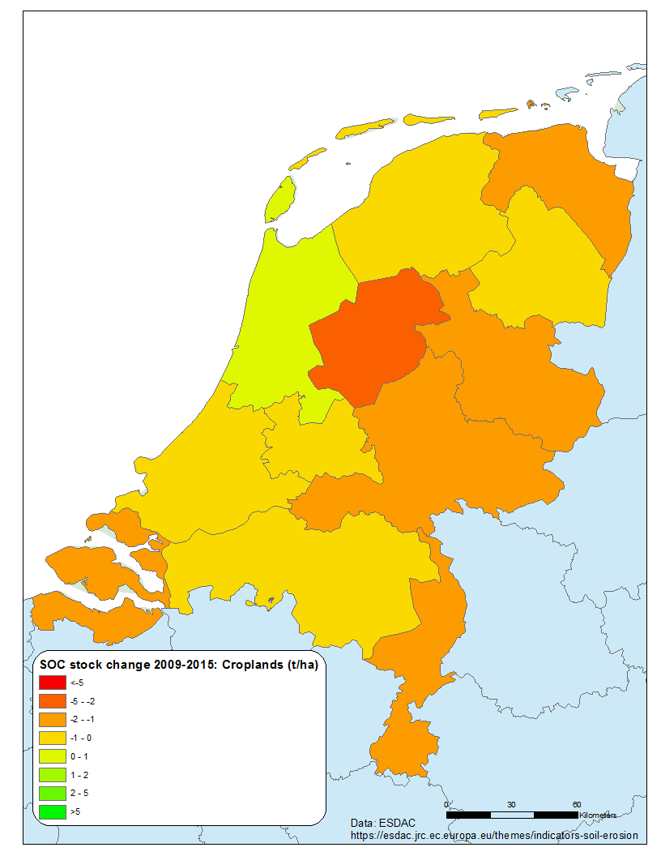

|  |  |
| --- | --- |
|  |  |

Cumulative soil organic carbon stocks – arable (Mt): 86.6

Cumulative soil organic carbon stocks – grassland (Mt): 102.2

Change in arable stocks 2009-2015 (Mt): -0.090

Change in grassland stocks 2009-2015 (Mt): -0.033

**Risk of secondary salinisation**[5]

Limited data on state and trends of secondary salinization. NL has reported increased salinity in groundwater due to seawater incursions to aquifers. As NL is the 7th largest user of irrigation in EU, there are concerns on increased salt levels in agricultural lands.

Currently, there are no data at EU level for secondary salinisation due to sea water intrusions

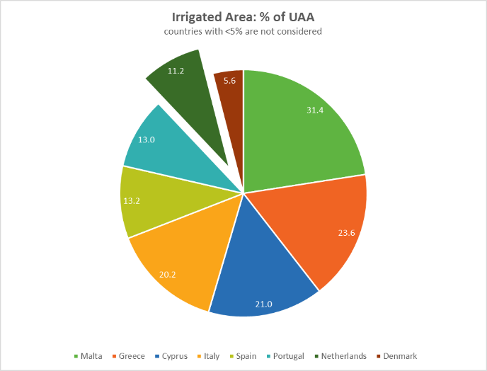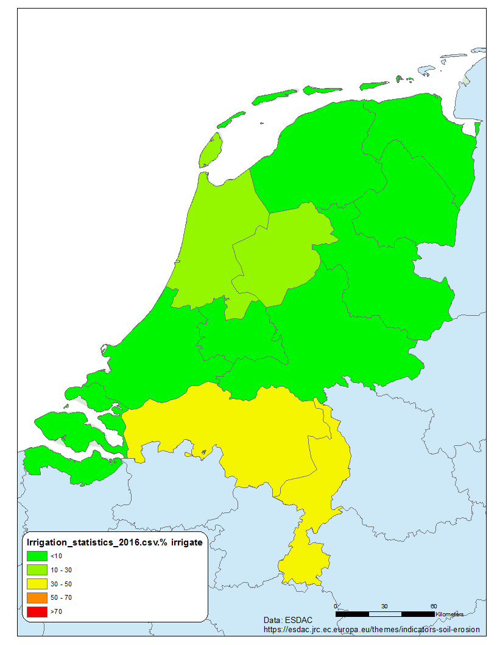

Mean EU-28: 5.9%

Netherlands: 11.2

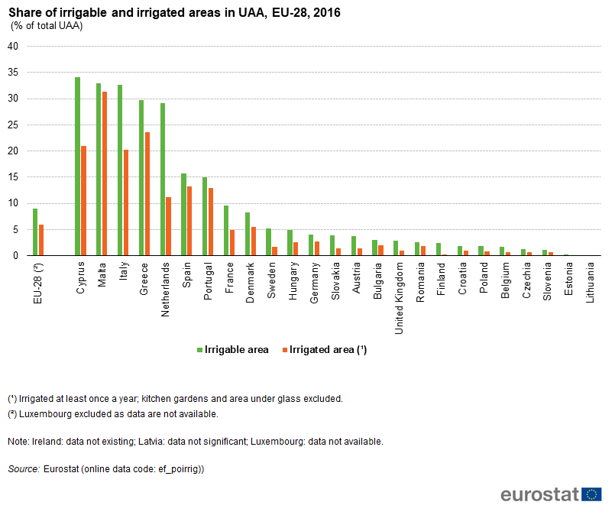

**Sealing[6][7][8]**

Soil sealing is a component of land take. Generally speaking, about 50% of land take results in sealed soils.

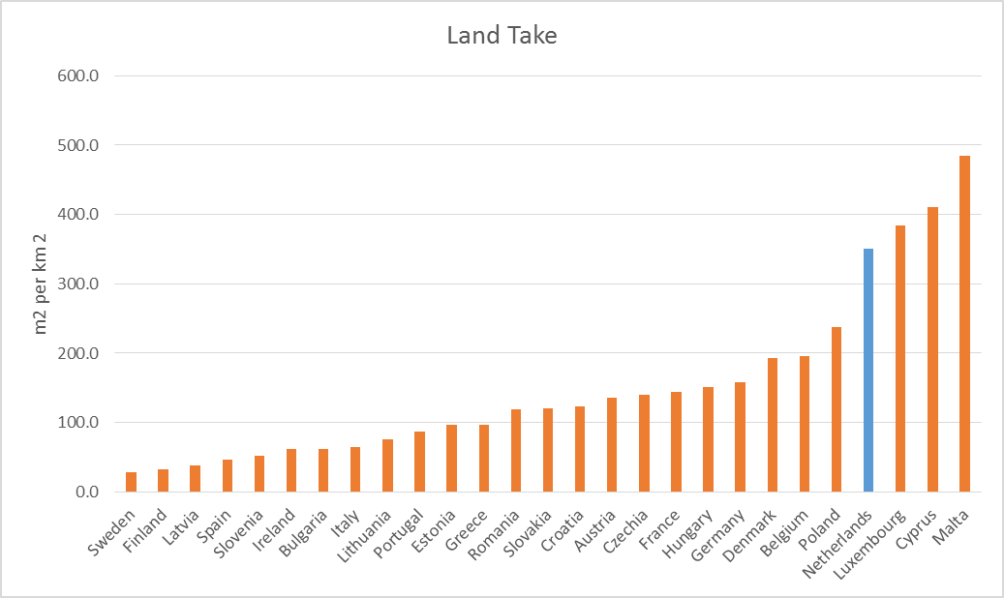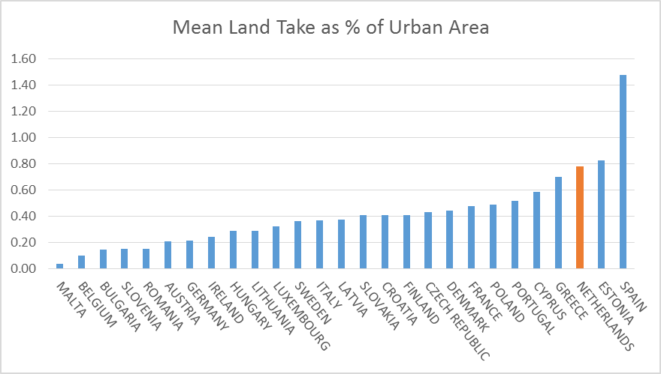

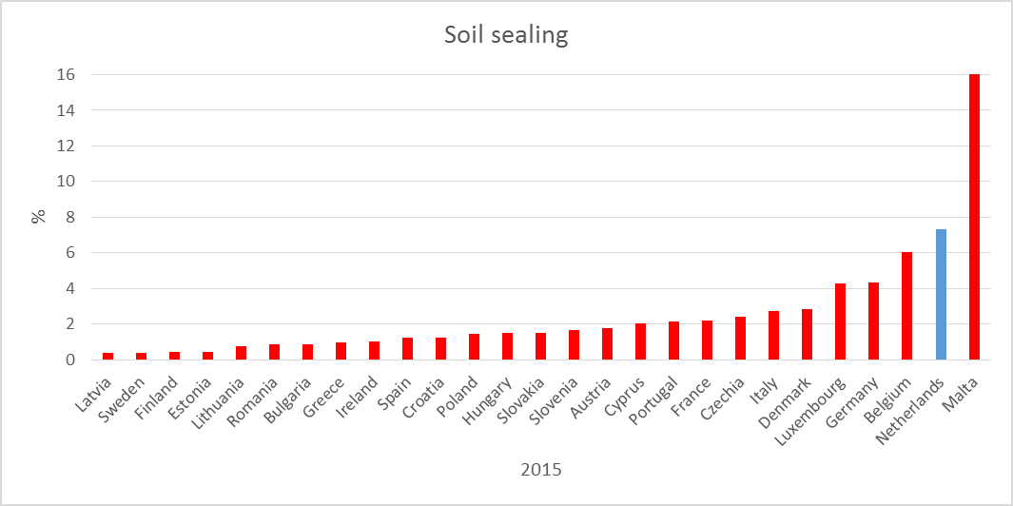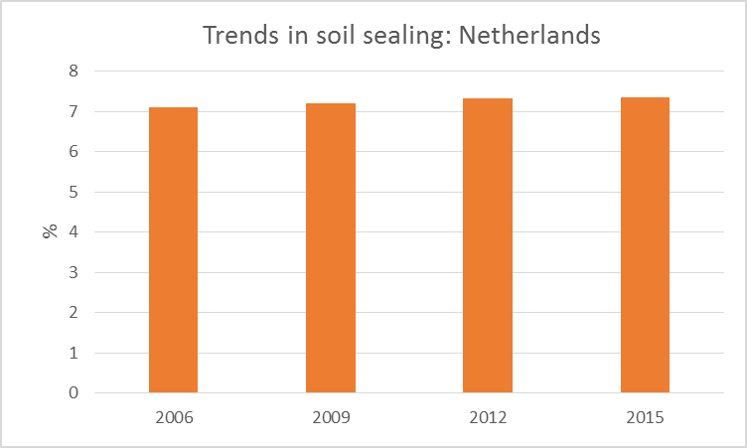

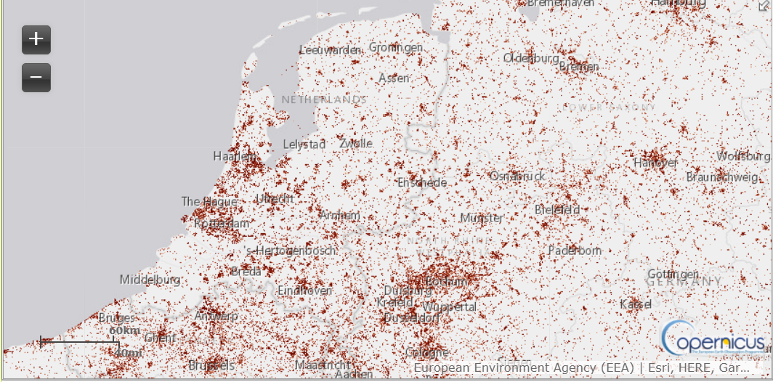

The extent of sealed soils

1. https://ec.europa.eu/eurostat/web/lucas/data/database
2. https://ec.europa.eu/eurostat/statistics-explained/index.php/Agri-environmental_indicator_-_irrigation
3. https://esdac.jrc.ec.europa.eu/themes/indicators-soil-erosion
4. Panagos et al 2020. Soil-related indicators to support agri-environmental policies
5. <https://ec.europa.eu/eurostat/statistics-explained/index.php/Agri-environmental_indicator_-_irrigation#Analysis_at_EU_and_country_level>
6. https://www.eea.europa.eu/airs/2018/natural-capital/urban-land-expansion
7. https://www.eea.europa.eu/data-and-maps/indicators/land-take-3/assessmen
8. https://land.copernicus.eu/pan-european/high-resolution-layers/imperviousness/status-maps/imperviousness-density-2018